Exadel
Automated Attributes Test Application
Test Plan
Contents
1. Revisions 3
2. Introduction 4
3. Testing Environment 4

Revisions
Date | Revision Number | Author | Description

Introduction
This document is used to help to develop a specific test application with automated tests for checking as much attributes as possible.
The purpose of this document is to act as a vehicle for communicating understanding on the following:
- Define the common architecture of the application
- Split development for tasks
- Describe each concrete part of the application

Common application view
JSP application will be used as a basis for the automated attributes tests. QC engineer (or ‘user’ in the text below) should have the next common possibilities.

TLD parser
Taglib parser is necessary to define all the attributes implemented for each component. It should be a Java class included into test application. This class should be common for all the components. It should be able to return all the attributes for any Rich Faces component. It should also have three methods, each one of them should:
- Return all the event handlers, implemented in the current component
- Return all the style- and styleClass- attributes implemented in current component
- Return all the other general attributes implemented in current component

Rich.jsp
User should have an opportunity to select, whether to perform tests manually or automatically. This should be implemented as radio-button with two states ‘Auto’ – for auto tests and ‘Manual’ – for executing manual tests. These buttons should be displayed at ‘webapp\pages\Rich\Rich.jsp’ page. In case of ‘Auto’ option – ‘Auto .jsp’ is included into ‘webapp\pages\Rich\Rich.jsp’, in case of ‘Manual’ option – ‘<ComponentName>.jsp’ and ‘<ComponentName>Property.jsp’ pages should be included.

Auto.jsp
A different JSP page should be added into the folder of each component. This page should be named as ‘Auto.jsp’. See image below:
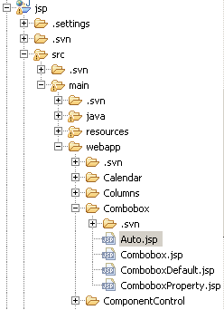

Component
The component under testing should displayed at the top. Existing Java classes may be used for defining component’s state.

Three panels for test results
There should be three panels for test results:
- For general component attributes test results
- For event handlers test results
- For style- and styleClass- test results

Each panel should look like a table:
<attribute name> | <test status> | <optional control>
<attribute name> | <test status> | <optional control>
<attribute name> | <test status> | <optional control>

Each panel is displayed by click on one of three buttons:
- <Check general attributes>
- <Check event handlers>
- <Check styles/styleClasses>

Managed bean for auto tests
Each component should have a new managed bean.

There should be three local variables. Each one of them should contain a list of attributes of type Attribute:
- A list of general attributes
- A list of event handlers
- A list of styles and styleClasses

ArrayLitst’s each one should contain Each general attribute implemented in the component under testing should have its own test-method.

Event handlers …
Styles/styleClasses …

Test methods
Test method should have name like check<attribute name>();

There should be three following methods implemented.

checkGeneralAttributes();

